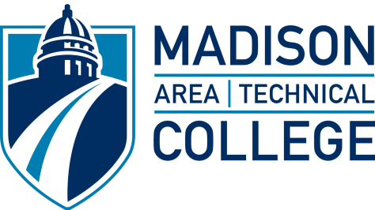

October 28, 2021

MEETING NOTICE

NOTICE IS HEREBY GIVEN that the Madison Area Technical College District Board will meet in open session, in a hybrid format, at 1701 Wright Street, Room D1630B/C, at 3:30 PM on Wednesday, November 3, 2021, to participate in a budget retreat. Members of the public can monitor the meeting by dialing (608) 620-8501 and entering Conference ID 313 032 259# when prompted.

NOTICE IS FURTHER HEREBY GIVEN that the Madison Area Technical College District Board will meet in executive session, in a hybrid format, at 4:30 p.m. in AB132 to consider employment, promotion, compensation or performance evaluation data as authorized in Section 19.85 (1) (c), Wis. Stats., and for the purpose of receiving an update on strategy, and terms and conditions, concerning negotiation of the acquisition of real estate as authorized by Section 19.85 (1) (e) Wis. Stats. The meeting will begin and end in open session. Members of the public can monitor the open portion of this meeting, both before and after the executive session, by dialing (608) 620-8501 and entering Conference ID 905 101 355# when prompted.

NOTICE IS FURTHER HEREBY GIVEN that immediately following executive session, and anticipated no earlier than 4:45 p.m., the Madison Area Technical College District Board will meet in open session in Room AB132, in a hybrid format. Members of the public can monitor the open portion of this meeting, both before and after the executive session, by dialing (608) 620-8501 and entering Conference ID 905 101 355# when prompted.

NOTICE IS FURTHER HEREBY GIVEN that the Madison Area Technical College District Board will meet at 5:30 p.m. at 1701 Wright Street, Room D1630B/C, in a hybrid format, to consider the items below. Members of the public can monitor the meeting by dialing (608) 620-8501 and entering Conference Code 513 325 643# when prompted.

I. CALL TO ORDER

A. Compliance with Open Meeting Law

II. ROUTINE BUSINESS MATTERS

- Approval of October 6, 2021, Meeting Minutes
III. NEW BUSINESS

- Communications

1. Board Chair’s Report

  - Future Meeting & Event Schedule

2. Student Liaison Report

3. College/Campus Announcements

4. President’s Report

a. Employee Benefits Review for 2022 Plan Year

B. Information Items

1. FY2020-21 Preliminary Audit Results

C. Action Items

1. Fiscal Year 2020-21 Budget Adjustments

2. Resolution on District Reserves and Designations

3. Capital Projects Borrowing

- Resolution Authorizing the Issuance of Not To Exceed $3,500,000 General Obligation Promissory Notes, Series 2020-21F
- Resolution Establishing Parameters for the Sale of Not to Exceed $3,500,000 General Obligation Promissory Notes, Series 2020-21F

4. New Program Approval – Barber Apprenticeship

5. Consent Agenda

- General fund financial report as of September 30, 2021
- Request for proposals/request for bids/sole sources
- Quarterly investment report
- Quarterly finance dashboard
- Vendor payments greater than or equal to $2,500 and schedule of checks issued for the period September 16, 2021, through October 15, 2021
- September 38.14 service contracts
- Employment of personnel
- Resignations and separations

IV. CALENDAR OF EVENTS

Board Meetings
November 3, 2021
December 1, 2021
January 5, 2022

Wisconsin Technical College District Boards Association
January 27-29, 2021; Elkhart Lake (Lakeshore Technical College)

Association of Community College Trustees
National Legislative Summit – Washington, DC; February 6-9, 2022

V. ADJOURN

cc:
News Media
Madison College Board
Legal Counsel
Administrative Staff
Full-Time Faculty/ESP Local 243
Part-Time Faculty

